SEARCH CONDITIONS

Where Clause:
1) The Where clause allows you to specify a search condition for the rows returned by a query.
2) Where Clause is use for to filter the record.
3)The WHERE clause is used to extract only those records that fulfill a specified condition.
Syntax:
select column_list from tableName where serach_condition;

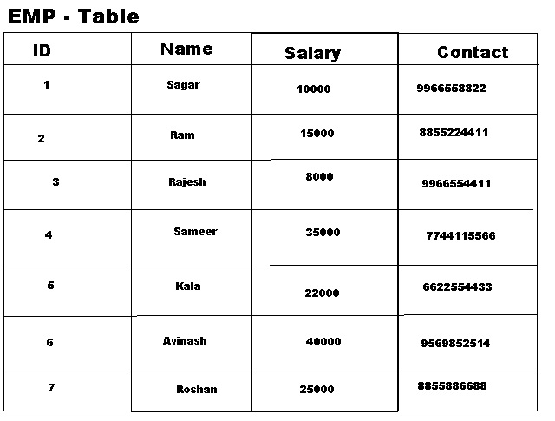

Filter Example:
1) Select * from emp where id=3;
2) Select id,name,salary from emp where id=5 and name='Kala';
3)select * from emp where id=5 or id=6 or id=4;
4) Select id,name,contact,salary from emp where id between 1 and 5
5) select * from emp where salary >20000;
6) select * from emp where salary >20000 and salary <40000

COMPRASIONS operators

Comparison operators :
are used in the WHERE clause to determine which records to select. Here is a list of the comparison operators that you can use in MySQL.
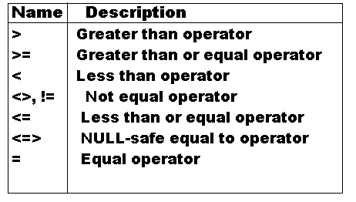
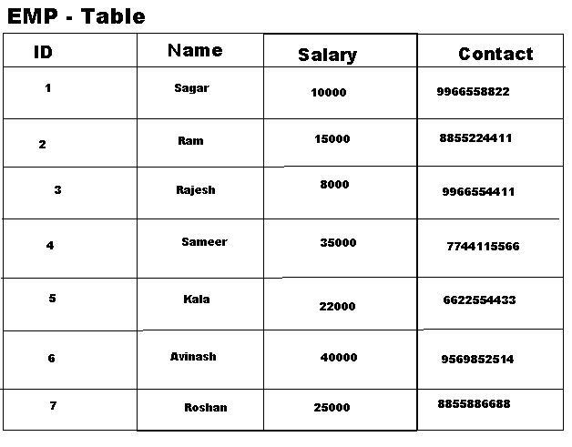
1) select * from emp where id=1 or id=2
2) select * from emp where id>1 and id<5
3)select * from emp where salary>=1000 and salary<=40000;

IN operation

In Clause:
1) The function returns 1 if expr is equal to any of the values in the IN list, otherwise, returns 0.
2) It is used to help reduce the need for multiple Or condition in a SELECT, INSERT, UPDATE, or DELETE statement.
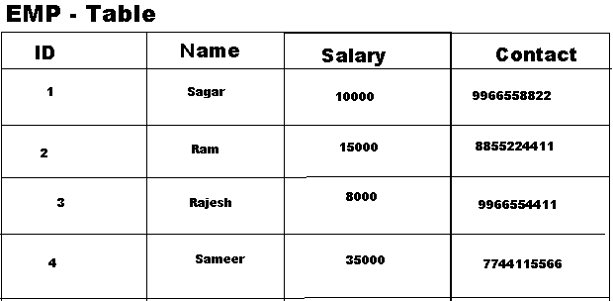
1) Select 10 in (12,10,45);
2)select * from emp where id in (1,2,3,6);
3)select * from emp where name in("Sameer",'Raj','Rajesh','Kala');
4)select * from emp where name not in("Sameer",'Raj','Rajesh','Kala');
5)select * from emp where salary in(10000,8000,40000,22000,35000);

